Graduating high school in Massachusetts? You won’t need the MCAS.
Hannah Hafner
Feb 22, 2026
Amid declining test scores, the Healey-Driscoll administration is working towards developing a new set of graduation requirements for Massachusetts high school students.
In the new proposed requirements, students will take end-of-course assessments and complete capstone projects instead of standardized tests (Statewide High School Graduation Framework Mass.gov, n.d.). They will also develop a career and academic plan, complete the FAFSA or MASFA, develop financial literacy, and have the option to earn state-wide seals of distinction.
This comes after nearly 60% of Massachusetts voters voted to eliminate passing the Massachusetts Comprehensive Assessment System (MCAS) exam as a high school graduation requirement in November 2024 (Farrar, 2024).
Supporters of the MCAS as a graduation requirement have argued that eliminating the test without a replacement in mind (at the time) was reckless (Farrar, 2024).
Opposition argued that a high-stakes test required to graduate disproportionately impacts marginalized communities (Lin & Schwartz, 2024).
The vote to remove the MCAS may in part have been precipitated by falling test scores.
In 2025, less than a quarter of sophomores at Smith Vocational and Agricultural High in Northampton met expectations on either section of the MCAS, according to state records.
Northampton High had steady performance in English, with Math dropping 7% between 2019 and 2025.
Even at Hopkins Academy in nearby Hadley, a school with above-average test-takers, the percentage of students meeting expectations fell 17% for English and 24% for Math from 2019-2025 (MCAS Data Trends by School, n.d.).
“Kids weren’t doing well on the MCAS, and it was a struggle because you were teaching to the MCAS, and not anything besides that.” says Riko Mukoyama, a student teacher in biology at Hopkins Academy who has also taught at Northampton High and Smith Vocational.
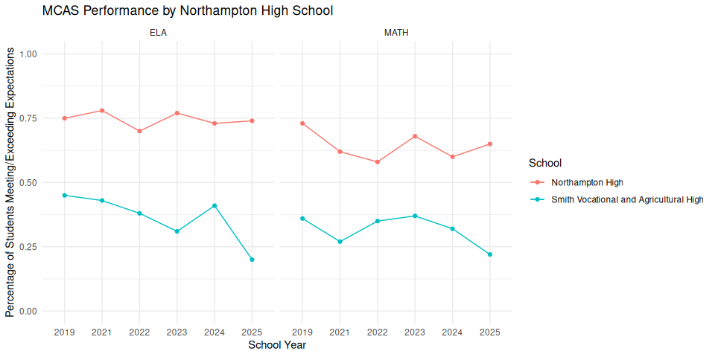
While the MCAS is no longer a graduation requirement, students still need to take the exam. Removing the MCAS as a requirement may have lowered students’ motivation to try on the test.
“You still have to devote the staff time and the student time to taking the test. Now students don’t have any particular incentive to take it that seriously, but schools are being held accountable for their MCAS scores,” says Lynn Dole, coordinator of teacher education at Smith College and former principal of Mohawk Trail Regional School and Greenfield Middle School.
“It’s hard to tell a 16-year-old that this exam matters, and they they should still try because it’s an important data point,” Mukoyama added.
Currently, the Healey-Driscoll administration is seeking public feedback to inform details of the new graduation requirements in an online survey (Statewide Graduation Council Input Form, n.d.).
“There should be more writing or a demonstration in a different format of understanding, which I think would be hard to implement across the state.” said Mukoyama
Importantly, the administration is soliciting additional suggestions on supporting student populations that need extra support.
In the coming months, the focus on graduation requirements in Massachusetts shifts away from standardized exams and towards the implementation of broader guidelines.
Farrar, M. (2024, November 6). Yes on 2: MCAS will no longer be high school graduation requirement. Boston.com. https://www.boston.com/news/politics/2024/11/06/yes-on-2-mcas-no-longer-be-high-school-graduation-requirement/
Lin, D. G., & Schwartz, E. T. (2024, November 6). Massachusetts voters approve proposition to eliminate MCAS graduation requirement news the harvard crimson. https://www.thecrimson.com/article/2024/11/6/voters-approve-mcas-ballot-question/
MCAS data trends by school. (n.d.). Retrieved February 22, 2026, from https://educationtocareer.data.mass.gov/stories/s/MCAS-Data-Trends-by-School/896r-8iup/
Statewide graduation council input form. (n.d.). Retrieved https://survey.alchemer.com/s3/8612728/Statewide-Graduation-Council-Interim-Report
Statewide high school graduation framework mass.gov. (n.d.). Retrieved February 22, 2026, from https://www.mass.gov/info-details/statewide-high-school-graduation-framework

